[ Insert official UPAEP logo ]
UPAEP · Decanato de Ingenierías
EVIDENCE — US15-T7
Build irrigation control and mode selector
SmartGreenAI: Cilantro Crop

1. Task information
Task ID | US15-T7
User Story | US-15 — Manually activate or deactivate irrigation
Sprint | Sprint 3 (2026-10-12 – 2026-10-30)
Week | Week 2
Responsible | Vicente Rocha Alfaro
Peer reviewer | Oscar Abraham Talavera Nava
Planned / actual hours | 2 h / 2 h
Completed on | October 23, 2026
Status | Done

2. Task description
Add ON/OFF buttons with confirmation and duration selector, and a MANUAL/AUTOMATIC mode switch per area. Buttons are disabled in AUTOMATIC mode.

3. Completion conditions
✓ Condition 1: Buttons ask for confirmation.
How it was verified: Both the mode switch and the irrigation buttons ask for confirmation (with the duration for irrigation).
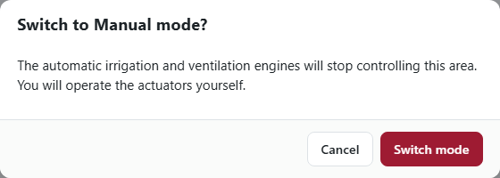
Figure US15-T7-1. Switching to Manual asks for confirmation. (US15-T7_Build_Irrigation_Control_Mode_Selector_2.png)
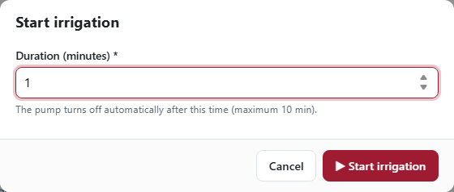
Figure US15-T7-2. Starting irrigation asks for the duration and a confirmation. (US15-T7_Build_Irrigation_Control_Mode_Selector_6.png)
✓ Condition 2: The mode switch is saved in the database.
How it was verified: The MANUAL/AUTOMATIC switch is saved in the database through PATCH /areas/AREA-1/mode.
Mode saved in the database (1 rows; US15-T7_Build_Irrigation_Control_Mode_Selector_3.csv)
id | name | mode | updated_at
AREA-1 | Cultivation Area 1 | MANUAL | 2026-09-29T04:40:10.738Z
SQL: SELECT id, name, mode, updated_at FROM areas WHERE id = 'AREA-1'
✓ Condition 3: The panel shows the new state.
How it was verified: The panel shows the new state after the command is executed.
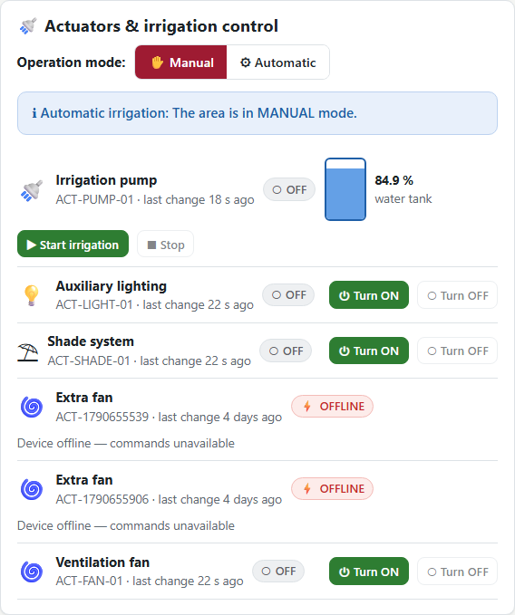
Figure US15-T7-3. MANUAL mode: Start irrigation / Stop and Turn ON / OFF buttons are enabled. (US15-T7_Build_Irrigation_Control_Mode_Selector_5.png)
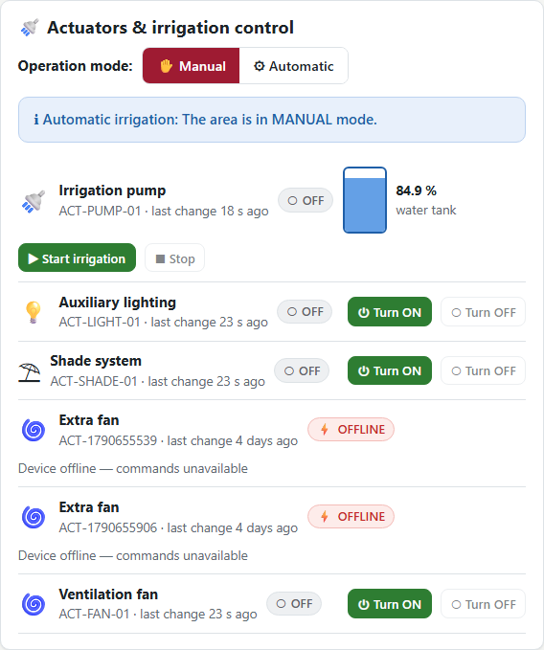
Figure US15-T7-4. After the device executed the command, the panel shows the pump ON. (US15-T7_Build_Irrigation_Control_Mode_Selector_7.png)
✓ Condition 4: Evidence: Screenshots before and after activating irrigation.
How it was verified: Screenshots before (AUTOMATIC, buttons disabled) and after activating irrigation.
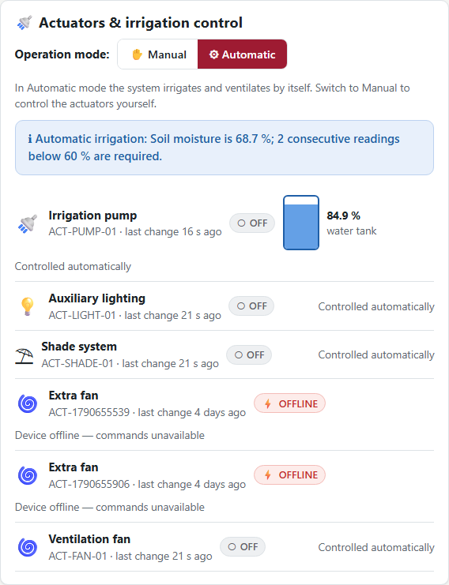
Figure US15-T7-5. AUTOMATIC mode: the ON/OFF buttons are not available ("Controlled automatically"). (US15-T7_Build_Irrigation_Control_Mode_Selector_1.png)

4. Attached files
- US15-T7_Build_Irrigation_Control_Mode_Selector_1.png
- US15-T7_Build_Irrigation_Control_Mode_Selector_2.png
- US15-T7_Build_Irrigation_Control_Mode_Selector_3.csv
- US15-T7_Build_Irrigation_Control_Mode_Selector_4.sql
- US15-T7_Build_Irrigation_Control_Mode_Selector_5.png
- US15-T7_Build_Irrigation_Control_Mode_Selector_6.png
- US15-T7_Build_Irrigation_Control_Mode_Selector_7.png

5. Traceability
Related requirements | FR-16, FR-17
Implementation | producer-dashboard.js → renderActuators(), changeMode(), sendCommand() (confirmation + duration)
Verification | e2e/irrigation.spec.js

6. Sign-off
Role | Name | Date | Signature
Responsible | Vicente Rocha Alfaro | October 23, 2026
Peer reviewer | Oscar Abraham Talavera Nava | October 23, 2026
Product Owner acceptance | Alexis Enrique Valle Parra | October 23, 2026
Approval record: Daily Meeting 3 of Sprint 3 (Monday, October 26, 2026), team update, Vicente Rocha Alfaro: "Finished US15-T7, irrigation control and MANUAL/AUTOMATIC selector." Daily Meeting 3 of Sprint 3 (Monday, October 26, 2026), Scrum board: "Tasks moved to Done last week: US11-T3, US11-T4, US11-T5, US12-T2, US13-T3, US15-T6, US15-T7, US16-T3, US16-T4, US17-T2, US19-T4, US19-T5, US19-T6."

